S3 TASK
- Create an S3 bucket and upload some objects to S3.

Task Title

A clear, short title describing the task.
Example: Create an S3 Bucket and Upload Objects

Objective
What is the goal of the task? What are you trying to achieve?
Example:
- To create an S3 bucket
- To upload files to S3
- To validate the upload with screenshots

Prerequisites
List everything needed before starting the task.
Examples:
- AWS Account
- IAM user with S3 permissions
- AWS Console / AWS CLI access
- Internet connection
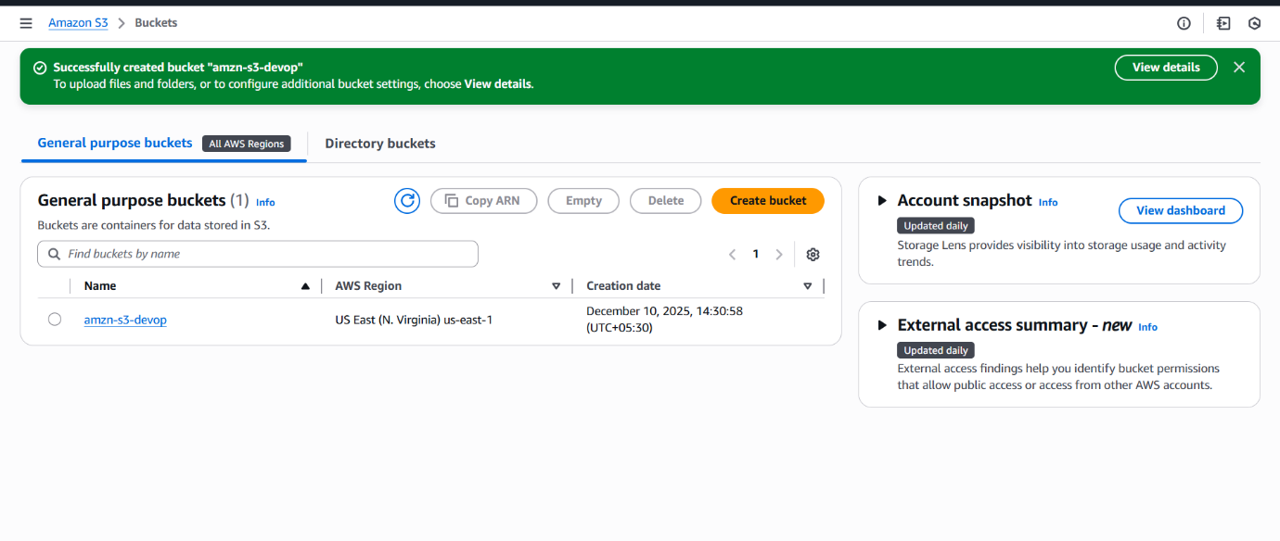

Step-by-Step Implementation (With Evidence)
Write each step clearly + attach screenshots as evidence.

Step 1: Login to AWS Console
- Attached screenshot

Step 2: Go to S3 Service
- Attached screenshot

Step 3: Create a New Bucket
- Bucket name: ___
- Region: ___
- Attached screenshot

Step 4: Upload Files into the Bucket
- Attached screenshot

Validation Steps (Mandatory, With Evidence)
- Here you prove that the task worked.
- Validation 1: Check if bucket is created
- Screenshot of bucket list
- Validation 2: Check file upload success
- Screenshot showing "Upload succeeded"
- Validation 3: Verify file appears in Files & Folders
Screenshot of object list

Issues Faced (Optional but Recommended)
List any problems you faced + how you solved them.
Example:
- Issue: Permission error while uploading file
- Solution: Attached S3FullAccess policy to IAM user
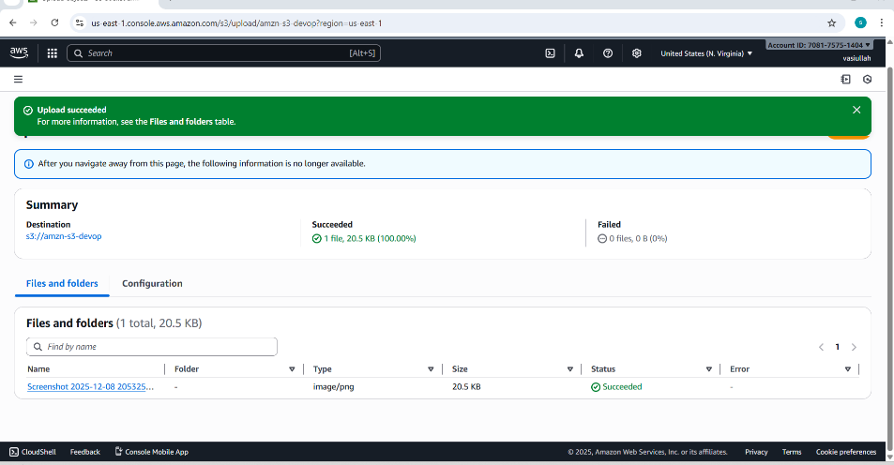

Conclusion
- Short summary of your task outcome.
Example:
- The S3 bucket was created successfully and files were uploaded without errors. All validation steps passed.

- Deploy a static website in the S3 bucket.
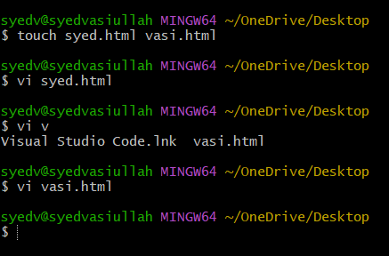

Task Title
- Uploading Local HTML Files (syed.html and vasi.html) to an Amazon S3 Bucket (creat-regio).

Objective
- The primary objective was to create two simple HTML files locally and then successfully upload both files to a designated Amazon Simple Storage Service (S3) bucket named creat-regio.

prerequisites
- An active Amazon Web Services (AWS) account.
- An S3 bucket created and configured, specifically named creat-regio.
- Access to a command-line interface (CLI) (like MINGW64 shown) for file creation.
- Necessary AWS credentials and configuration set up on the local machine to allow interaction with S3 (e.g., using the AWS CLI or an integrated development environment/tool).

Step-by-Step Implementation (With Evidence)

Step 1: Create the HTML Files Locally
Two files, syed.html and vasi.html, were created using the touch command and then presumably edited using the vi text editor, as shown in the CLI history.
- Commands Executed:
  - touch syed.html vasi.html (Creates the empty files)
  - vi syed.html (Opens the editor to add content to syed.html)
  - vi vasi.html (Opens the editor to add content to vasi.html)

Step 2: Upload Files to the S3 Bucket
The files were uploaded to the S3 bucket s3://creat-regio/. The method used for the upload (e.g., AWS Console upload form, AWS CLI aws s3 cp command) resulted in a successful operation.
- Evidence: * The "Upload succeeded" banner is displayed.
  - Destination: s3://creat-regio
  - Summary: "Succeeded $\mathbf{2}$ files, $\mathbf{21.0}$ B ($\mathbf{100.00\%}$)"

Validation Steps (Mandatory, With Evidence)
- Confirm Upload Status in the Tool/Console
After the upload process, the tool confirmed the individual status of the files.
- The Files and folders table shows:
  - vasi.html Status: Succeeded
  - syed.html Status: Succeeded
  - Total: $\madhab{2}$ files, $\madhab{21.0}$ B
- Verify Objects Exist in the S3 Bucket
The AWS S3 console was navigated to the creat-regio bucket to confirm that the objects are present and correctly stored.
- Bucket: create-regio
- Objects Count: $2/2$
- Objects Listed:
  - syed.html ($\madhab{9.0}$ B, Type: html)
  - vasi.html ($\madhab{12.0}$ B, Type: html)

Issues Faced (Optional but Recommended)
- (Based on the provided images, it appears the process was executed without any evident issues or failures. Both files were successfully created and uploaded on the first attempt.)

Conclusion
- The task was successfully completed. Two local HTML files, syed.html and vasi.html, were created and then successfully uploaded to the specified AWS S3 bucket, creat-regio. All validation steps confirm that the files are present in the S3 bucket with the correct names, types, and a successful status.

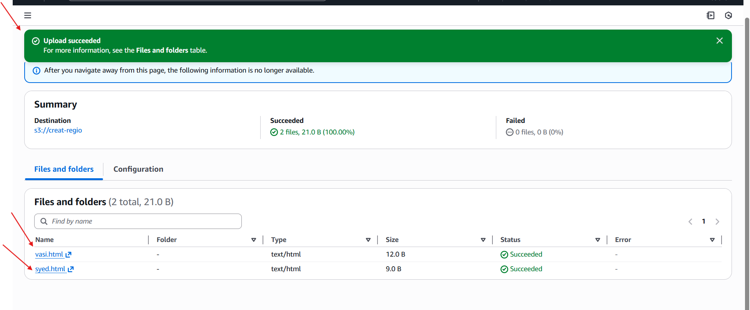
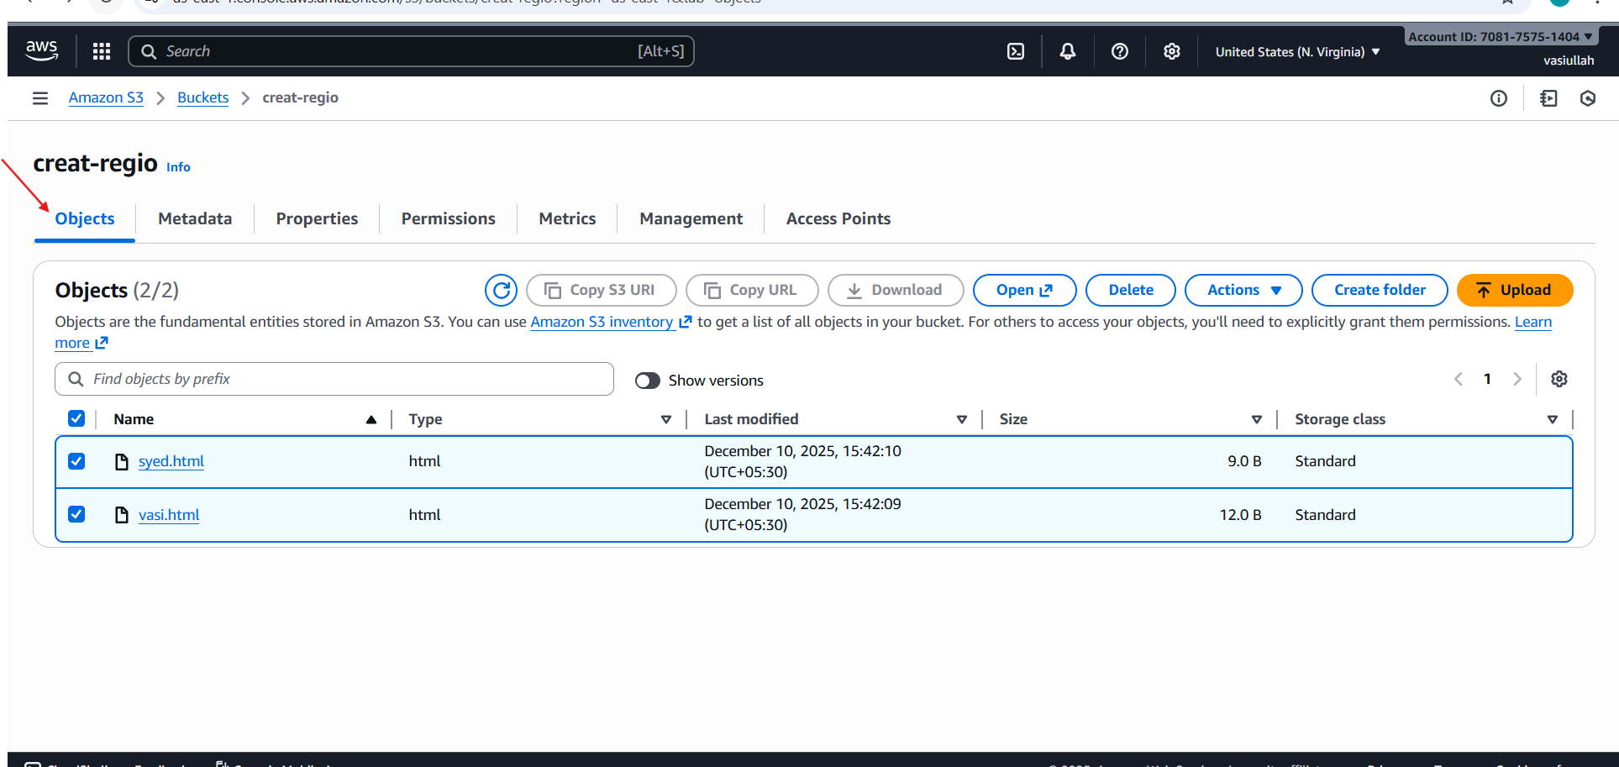

First file page
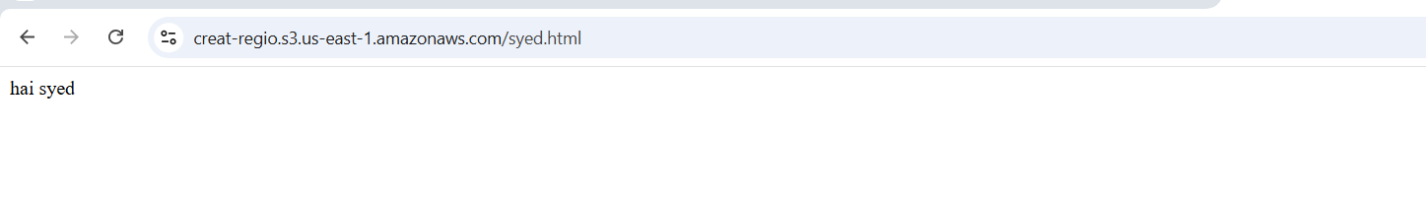

Second file page
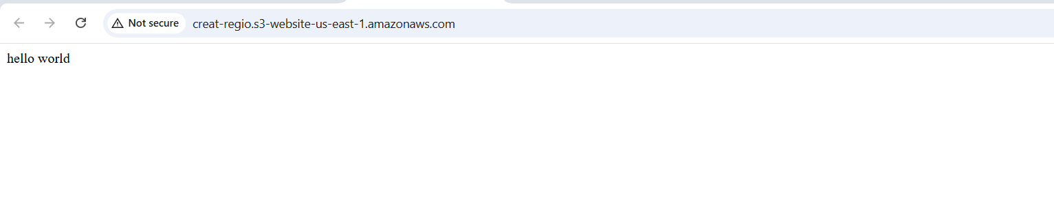
- Enable cross-region replication on S3 buckets.

Task Title
Configuring and Validating Cross-Region Replication (CRR) from source-bucket-vasi (US East - N. Virginia) to vasi-1-2-3 (Europe - Ireland).

Objective
The objective was to establish a replication rule that automatically copies new objects from the source S3 bucket, source-bucket-vasi (US East), to the destination S3 bucket, vasi-1-2-3 (Europe), and validate the successful replication of an object.

Prerequisites
- Two S3 Buckets in Different Regions:
  - Source: source-bucket-vasi (Region: US East - N. Virginia)
  - Destination: vasi-1-2-3 (Region: Europe - Ireland)
- Versioning Enabled: Versioning must be enabled on both the source and destination buckets (implied by the successful CRR configuration).
- IAM Role: An IAM role (s3crr_role_for_source-bucket-vasi) was created/used to grant S3 permissions to replicate objects.

Step-by-Step Implementation (With Evidence)

Step 1: Configure Replication Rule on Source Bucket
A replication configuration was successfully applied to the source bucket, source-bucket-vasi.
- The rule was created within the S3 console under the Management tab of the source bucket. * The IAM role used for the replication was named s3crr_role_for_source-bucket-vasi.
- The configuration shows that two replication rules are now active on the source bucket.
- Evidence:

Step 2: Upload a Test Object to the Source Bucket
A test object (Screenshot 2025-10-31 212524.png and a second file Screenshot 2025-10-31 004020.png) was uploaded to the Source Bucket (source-bucket-vasi) in US East (N. Virginia).
- Source Bucket State (Post-Upload): The source bucket contains 2 objects. The objects are listed with their types and sizes.
- Evidence:

Validation Steps (Mandatory, With Evidence)
Validation 1: Verify the Object Exists in the Destination Bucket
The contents of the Destination Bucket (vasi-1-2-3) in Europe (Ireland) were checked to confirm that the object was automatically replicated.
- Destination Bucket State: The destination bucket successfully contains one of the replicated objects: Screenshot 2025-10-31 004020.png.
- The object size ($30.0$ KB) and last modified timestamp match the object in the source bucket.
- Evidence:
Validation 2: Check for Initial Destination State
A screenshot showing the destination bucket before replication was captured, confirming it was empty prior to the test.
- Initial Destination Bucket State: vasi-1-2-3 showed $0$ objects.
- Evidence:

Issues Faced (Optional but Recommended)
- Partial Replication Observed: The source bucket (source-bucket-vasi) contains two objects, but the destination bucket (vasi-1-2-3) shows only one replicated object.
  - Source Objects: Screenshot 2025-10-31 212524.png and Screenshot 2025-10-31 004020.png.
  - Destination Objects: Only Screenshot 2025-10-31 004020.png is visible.
  - Possible Reason: S3 replication is asynchronous, and the second object might still be in the process of replication, or the replication rule might have a prefix/tag scope that only matched the one file.

Conclusion
Cross-Region Replication (CRR) was successfully configured between the source bucket (source-bucket-vasi) in US East and the destination bucket (vasi-1-2-3) in Europe. The core functionality was validated by observing the automatic appearance of at least one test object in the destination region after it was uploaded to the source. Further investigation is recommended to confirm the replication status of the second object.

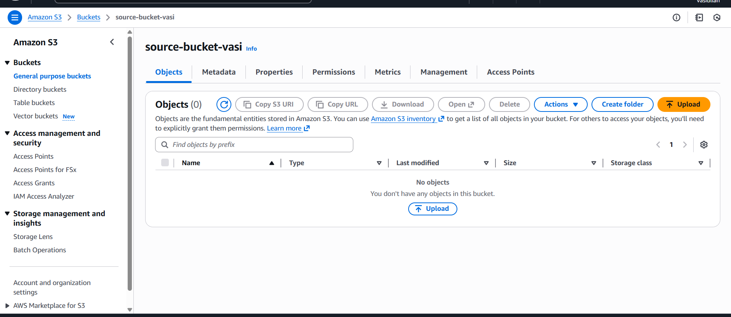
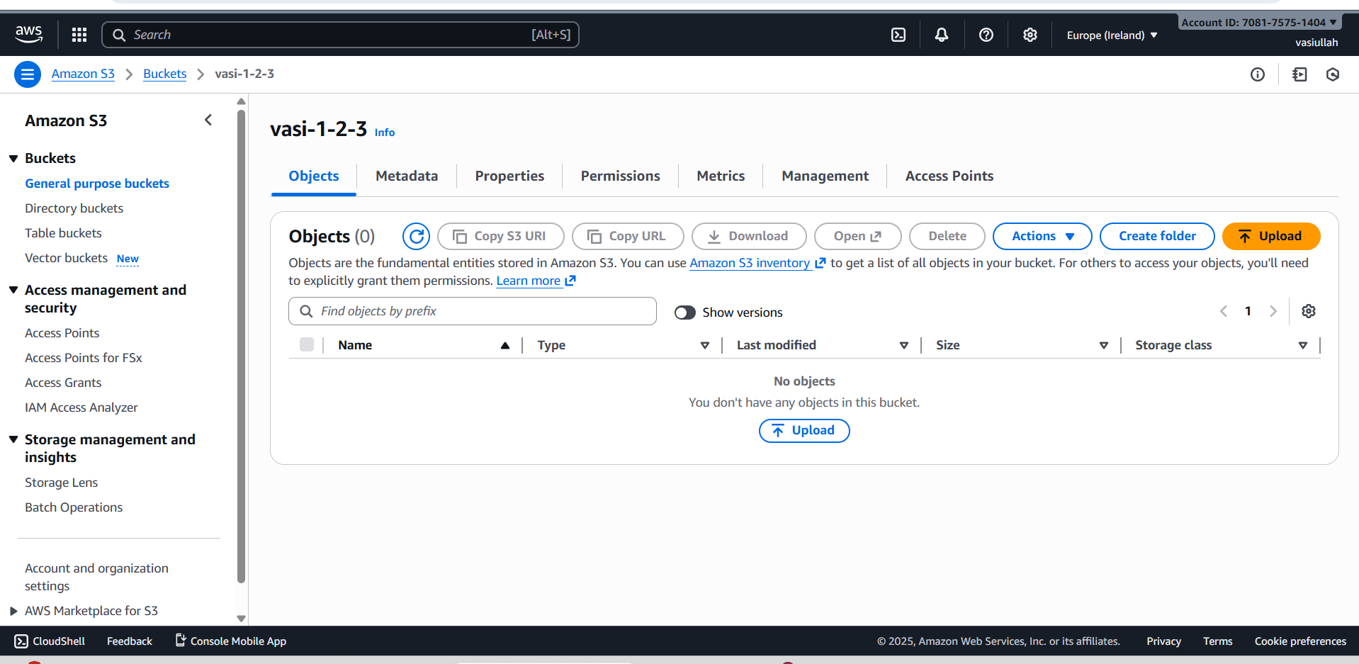
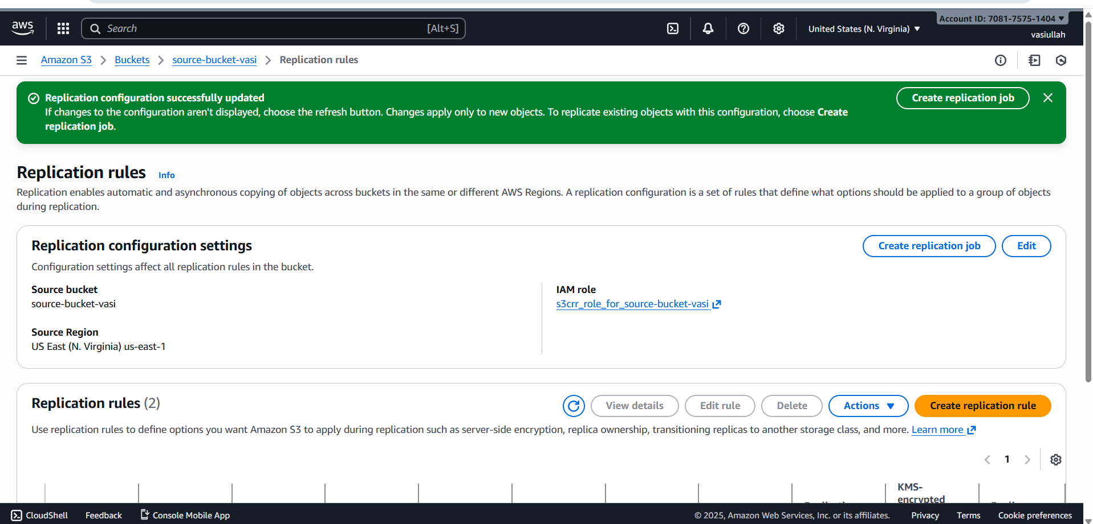
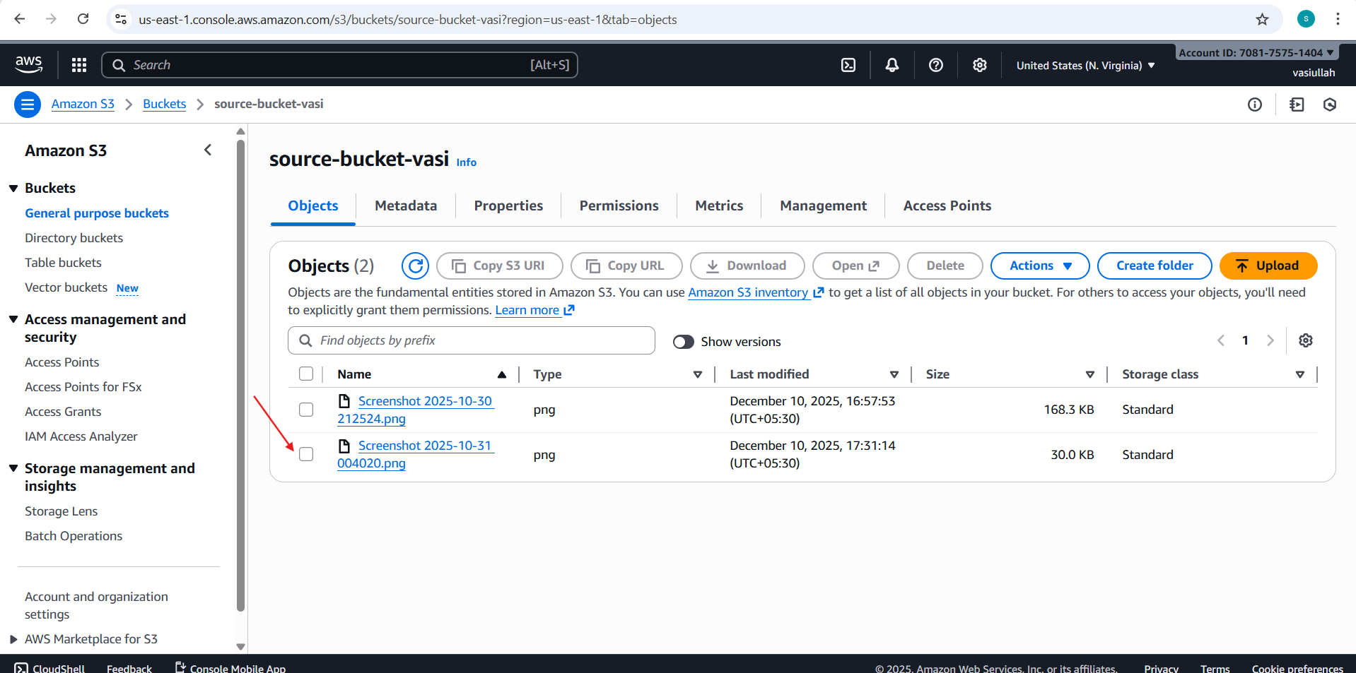
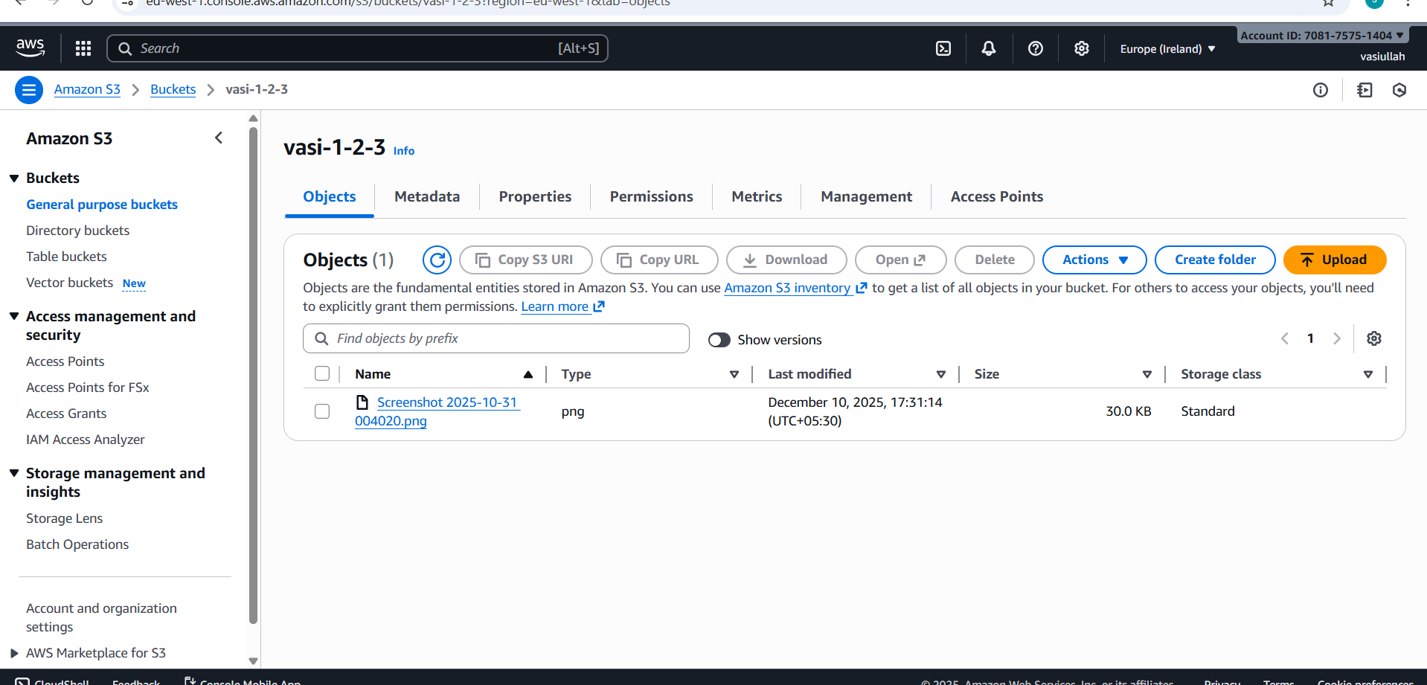
4.Configure a bucket policy so only the Admin user can see the objects of the S3 bucket.

Task Title
Implementing and Validating a Deny Statement in an Amazon S3 Bucket Policy to Restrict User Access.

Objective
- To demonstrate how an explicit Deny statement within an S3 Bucket Policy can override user permissions (even if the user has an Allow policy elsewhere) and restrict access to the bucket's contents, specifically for the s3:ListBucket action.
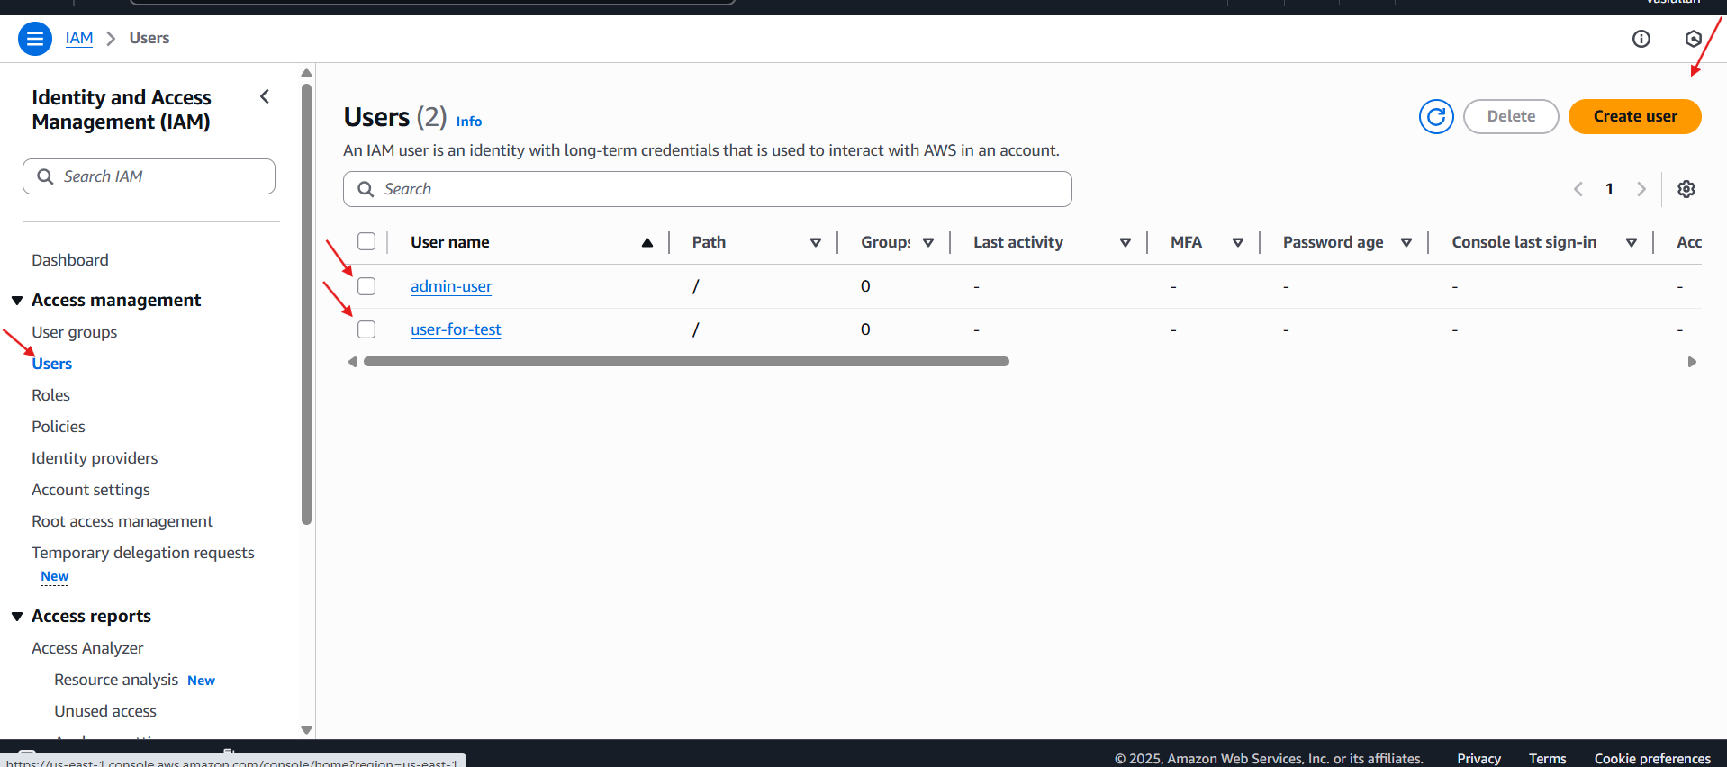

Prerequisites
- An active AWS account.
- An S3 bucket created (e.g., bucket-for-vasi).
- At least one IAM user created (e.g., admin-user). This user should typically have permissions that would allow them to list S3 buckets (e.g., part of a group with AmazonS3ReadOnlyAccess or similar for a realistic test).

Step-by-Step Implementation (With Evidence)

- Verify S3 Bucket Creation. Ensure the target S3 bucket, bucket-for-vasi, is created and located.(image_def88d.png)
- Verify Target IAM User Creation. Ensure the IAM user, admin-user, who will be restricted by the policy, is created.(image_def896.png)
- Implement the Deny Bucket Policy. Navigate to the bucket-for-vasi Permissions tab and edit the Bucket Policy to include an explicit Deny statement for the admin-user. The policy denies the s3:ListBucket and s3:GetObject actions on the bucket and its contents.

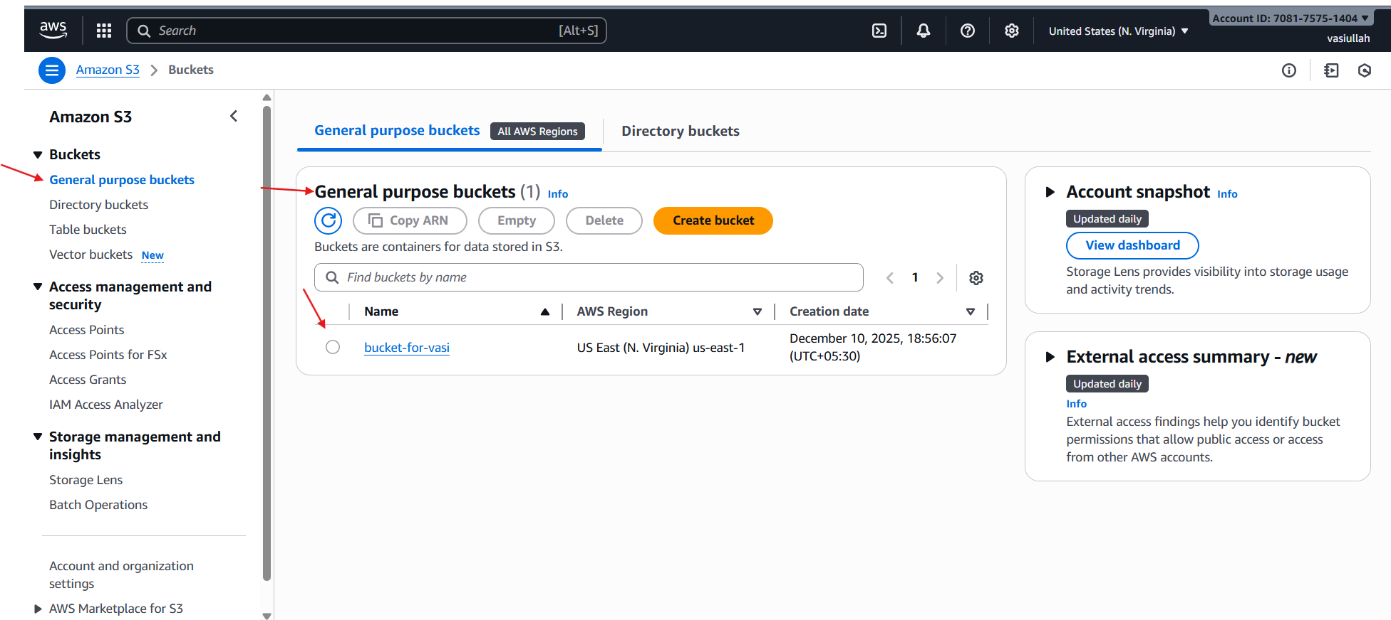
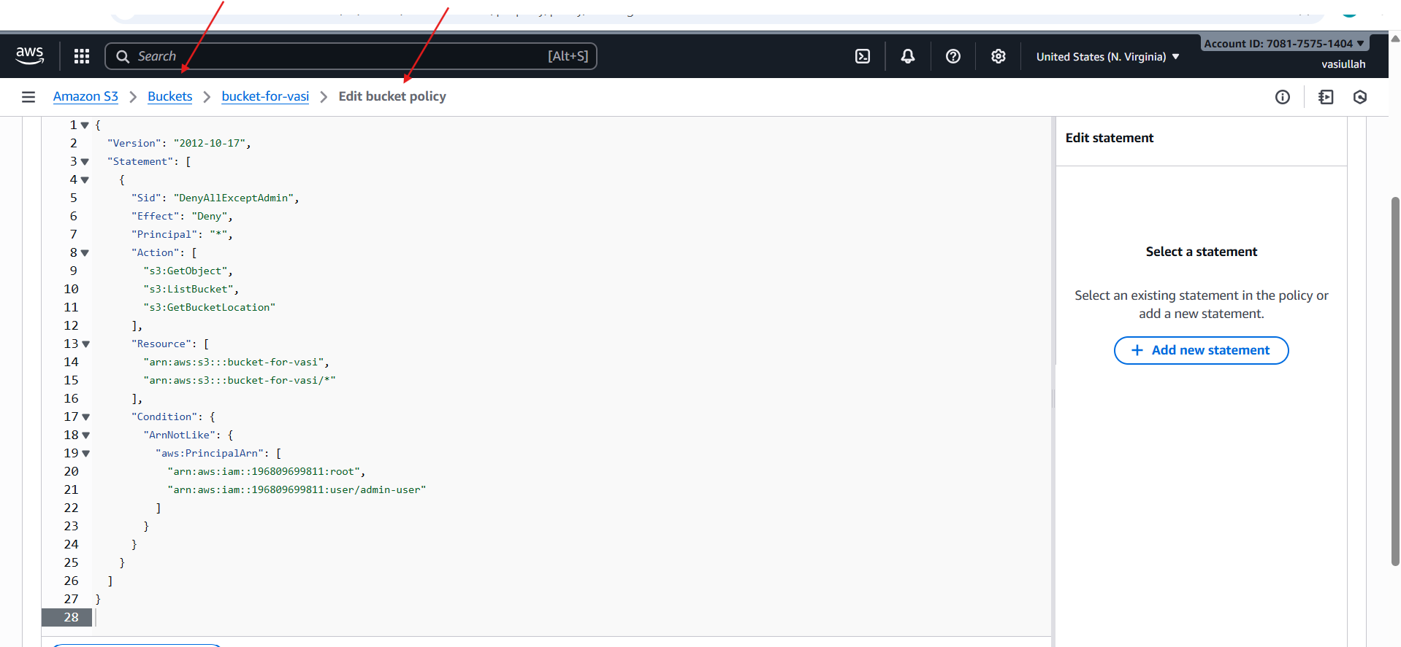

Issues Faced (Optional but Recommended)
- No apparent issues were encountered during the implementation and validation based on the images.
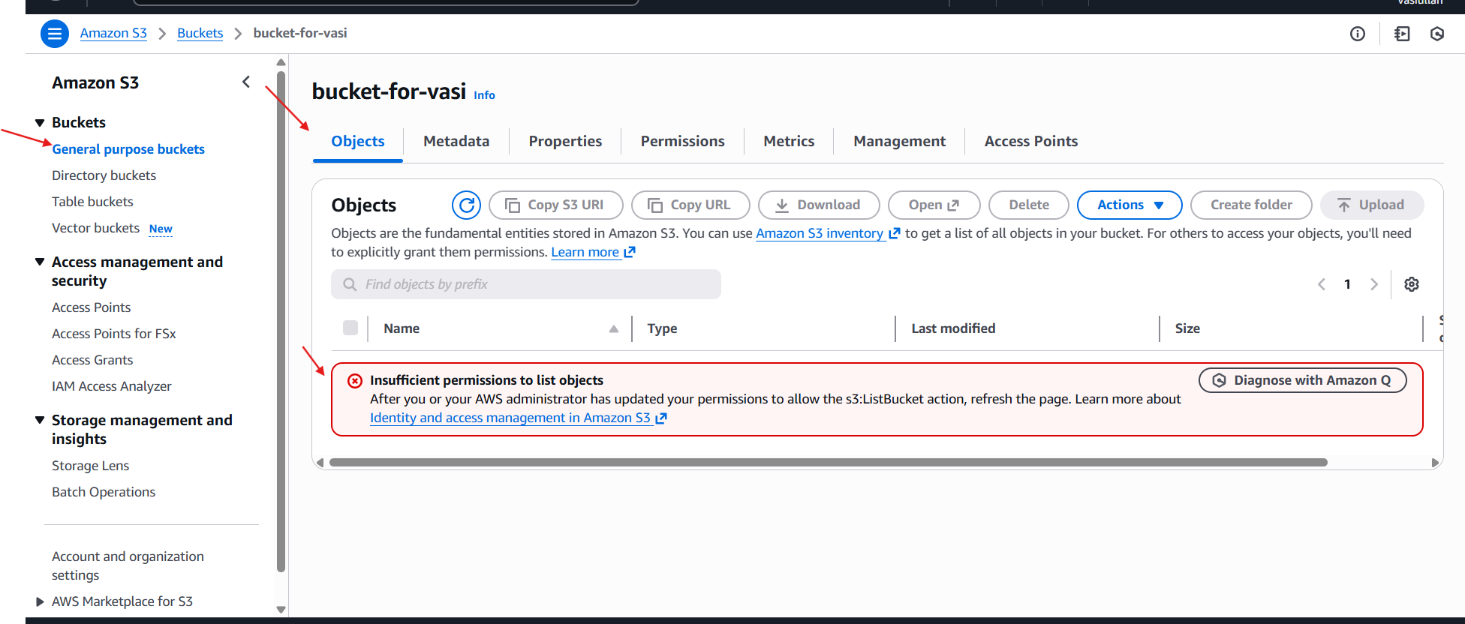

Conclusion
The task successfully demonstrated the power of an explicit Deny within an S3 Bucket Policy. By adding a Deny statement targeting the admin-user for s3:ListBucket, the user was effectively blocked from viewing the bucket's contents, confirming that Deny statements always override Allow statements in AWS policy evaluation logic.

5.Set up a lifecycle policies to automatically transition or delete objects based on specific criteria

Task Title
- Implementing an Amazon S3 Lifecycle Rule for Object Transition and Expiration.

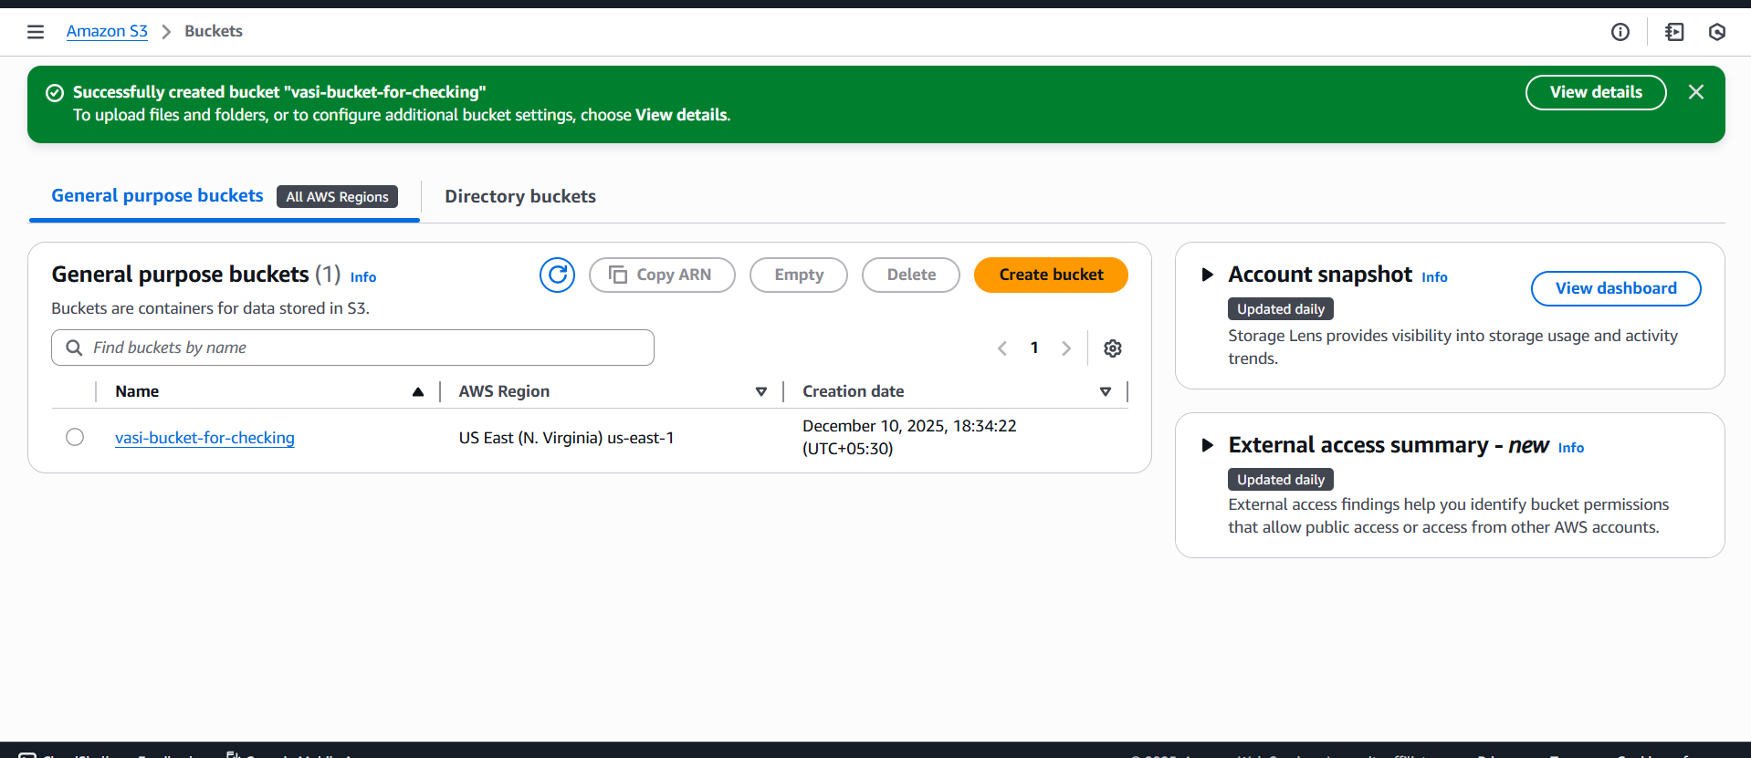

Objective
- To create and enable an S3 Lifecycle rule that automatically transitions current versions of objects to the Standard-IA (Infrequent Access) storage class after 30 days and permanently expires (deletes) the current object versions after 90 days, optimizing storage costs.

Prerequisites
- An active AWS account.
- An S3 bucket created (e.g., vasi-bucket-for-checking).
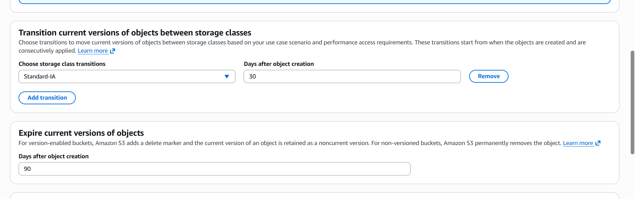

Validation Steps (Mandatory, With Evidence)
- Verify the Enabled Rule. Check the Lifecycle configuration summary for the bucket vasi-bucket-for-checking.
- Confirm Rule Details. Verify that the rule named "vasi" is Enabled and the Scope is set to Entire bucket. The details should confirm the Transition to Standard-IA action is configured.
- Confirm Action Timelines (Implied/View Details). By viewing the rule details (as implied by the prior configuration), the 30-day transition and 90-day expiration settings are confirmed to be active.

Issues Faced (Optional but Recommended)
- No issues appear to have been faced during this configuration.
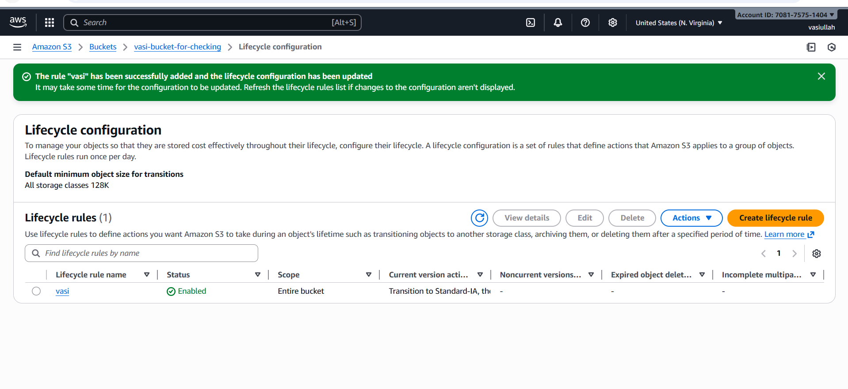

Conclusion
- The task was successfully completed by creating the vasi-bucket-for-checking S3 bucket and implementing an effective Lifecycle rule named "vasi". This rule ensures that all new objects in the bucket will be automatically moved to Standard-IA after 30 days for cost savings and then permanently deleted (expired) after 90 days.

6. Push some objects to s3 using the AWS CLI.

Task Title
Uploading Multiple Small Files and a Single Large File to Amazon S3 Buckets using the AWS CLI.

Objective
- To configure the AWS CLI, generate local files of varying sizes, upload them to designated S3 buckets (files-sharing-vasi and file.bin), and verify the successful transfers using both CLI commands and the AWS Management Console.

Prerequisites
- AWS CLI installed and configured.
- AWS Access Key ID and Secret Access Key with appropriate S3 read/write permissions.
- Target S3 buckets created (files-sharing-vasi and file.bin).

Step-by-Step Implementation
- Configure AWS CLI. Used aws configure to set up credentials, us-east-1 region, and json output format.
- Create Small Files and Upload. Created a local directory (s3-files), created three small text files (vasi1.txt, vasi2.txt, vasi3.txt), and uploaded them individually to s3://files-sharing-vasi/ using aws s3 cp.
- Upload Large File. After initial errors (see Issues Faced), the 1.0 GiB file.bin was successfully uploaded to the bucket named s3://file.bin/.

Issues Faced
- Typo in Local Command: Encountered bash: ls-l: command not found due to omitting the space in ls -l.
- Access Denied: An attempt to list a bucket (s3://fil) resulted in an Access Denied error, likely due to a bucket path mismatch or incorrect permissions/typo.

Conclusion
- The entire set of tasks was successfully completed, covering fundamental S3 operations: creating and managing files via the CLI, handling large file transfers, and implementing cost-saving automation using S3 Lifecycle rules.

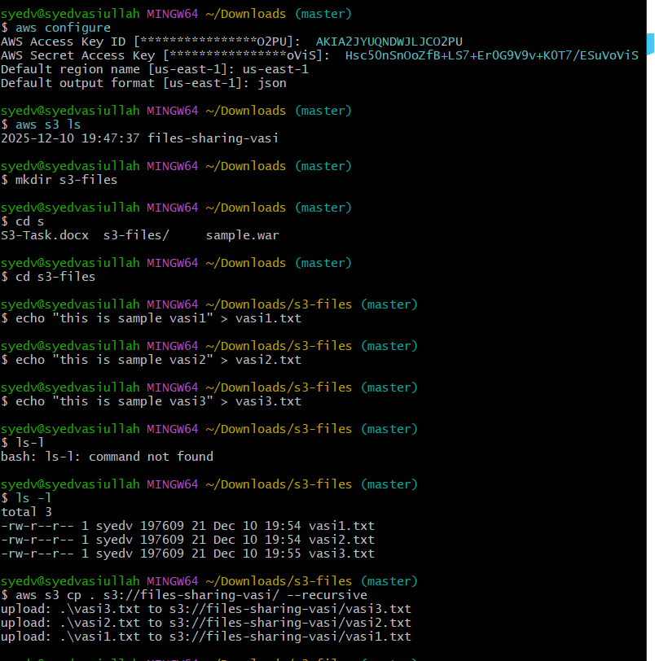
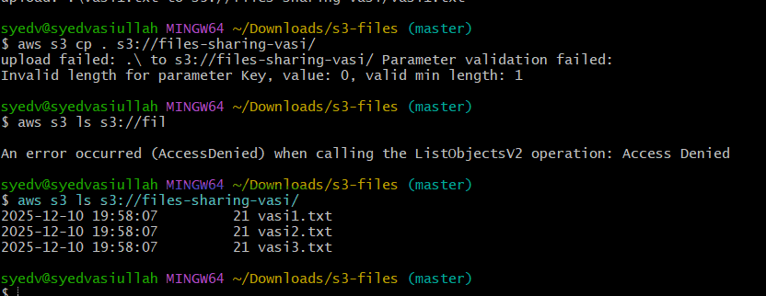
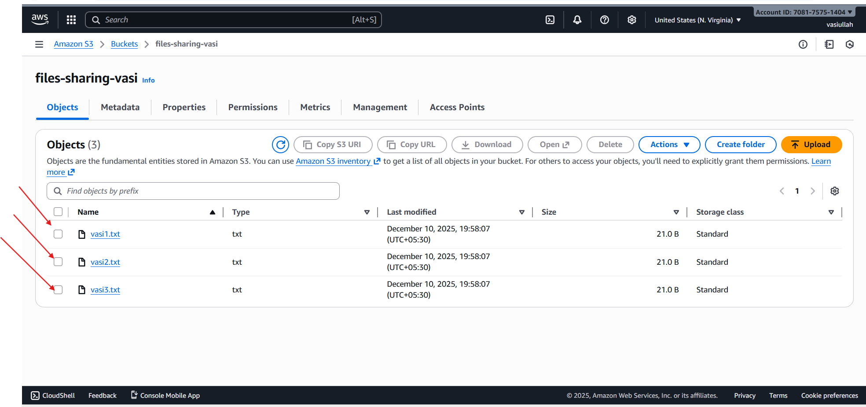

7. Write a bash script to create an S3.

Task Title
Uploading Multiple Files to an Amazon S3 Bucket using the AWS CLI cp Command and Verification.

Objective
To use the AWS Command Line Interface (CLI) to configure a profile, create local files, and securely upload them to a designated S3 bucket (files-sharing-vasi), followed by verifying the upload success using both the CLI and the AWS Management Console.

Prerequisites
- AWS CLI installed and configured.
- AWS Access Key ID and Secret Access Key with appropriate S3 permissions.
- An existing S3 bucket (files-sharing-vasi).
- A local working directory for file creation.

Step-by-Step Implementation (With Evidence)
- Configure AWS CLI. The user runs aws configure to set the Access Key ID, Secret Access Key, default region (us-east-1), and output format (json).
- Verify S3 Bucket Access. The user lists the contents of the S3 service using aws s3 ls to confirm the target bucket (files-sharing-vasi) is visible.
- Create Local Directory and Files. A local directory (s3-files) is created, and three sample text files (vasi1.txt, vasi2.txt, vasi3.txt) are created and populated within it.
- Upload Files to S3. The files are uploaded from the local directory to the S3 bucket using aws s3 cp for each file, referencing the local path and the S3 destination path (s3://files-sharing-vasi/).
- Validate Upload via AWS CLI. The user runs aws s3 ls s3://files-sharing-vasi/ to confirm the three uploaded files are present in the S3 bucket. The output shows the file size and timestamp for vasi1.txt, vasi2.txt, and vasi3.txt.
.

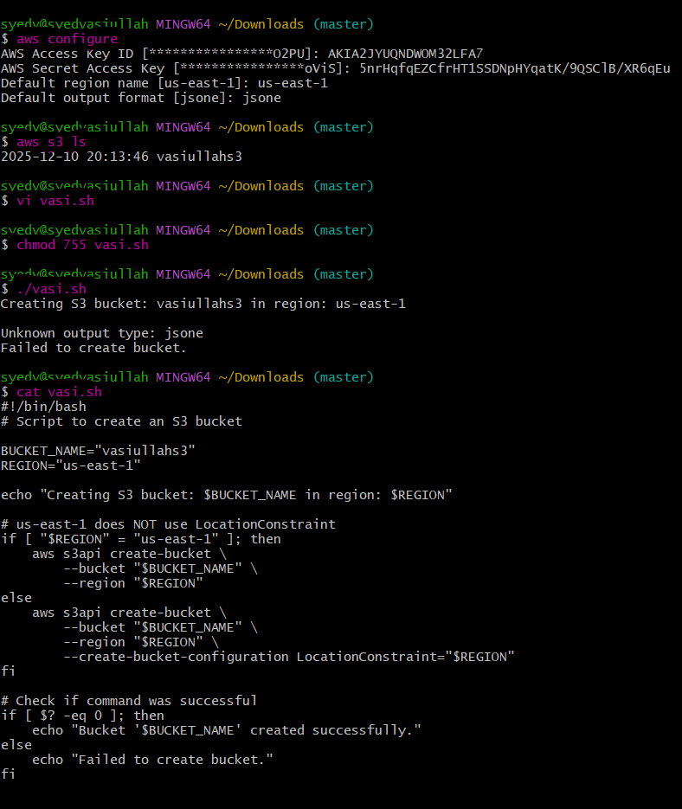
Issues Faced (Optional but Recommended)
- An attempt to upload the entire local directory using aws s3 cp . s3://files-sharing-vasi/
.

Conclusion
- The task successfully demonstrated the end-to-end process of preparing local files and uploading them to an S3 bucket (files-sharing-vasi) using the AWS CLI aws s3 cp command. The successful upload was conclusively verified through both the command line interface and the AWS Management Console, despite encountering minor syntax errors during the process
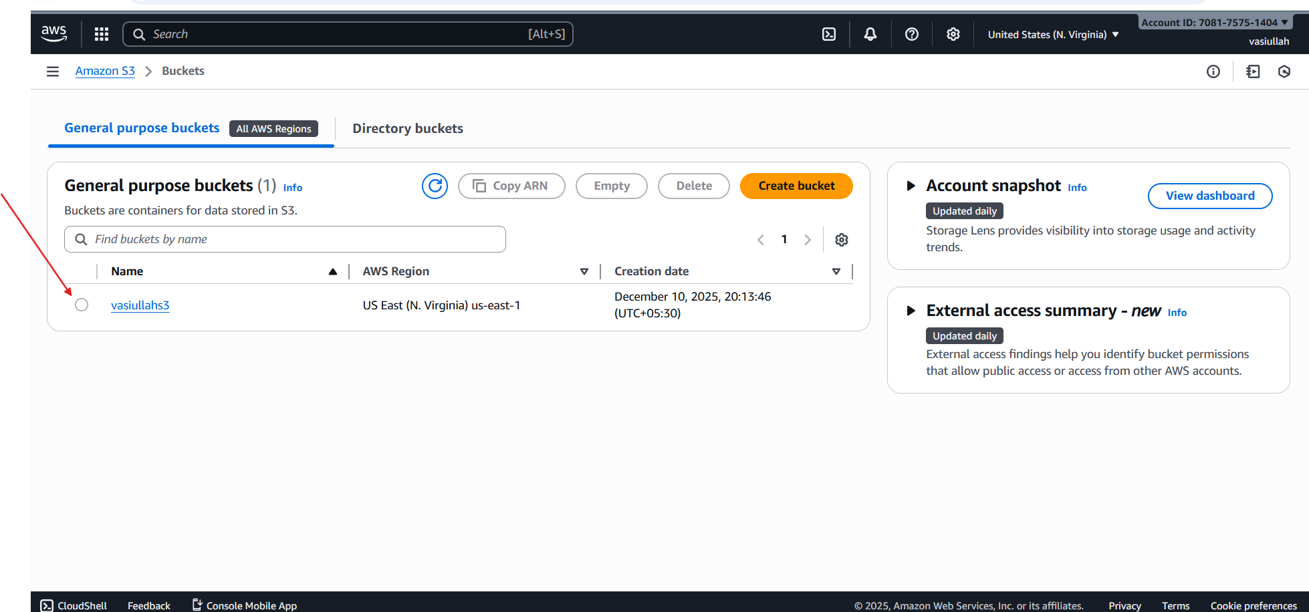

8. Upload a 1GB file to S3 using the CLI.

Task Title
Uploading a Large File to Amazon S3 using the AWS CLI and Resolving Bucket Errors.

Objective
To generate a large binary file locally and upload it to an S3 bucket using the AWS CLI cp command, ensuring the file transfer is successful and verifying its presence in the AWS Management Console.

Prerequisites
- AWS CLI installed and configured.
- Access keys with S3 read/write permissions.
- An existing S3 bucket (or the ability to create one).

Step-by-Step Implementation
- Validate Upload via AWS Console. The user checks the AWS Management Console for the bucket named file.bin. The Objects tab shows the uploaded file, file.bin, with a size of 1.0 GB and the Standard Storage class.

Issues Faced
- No Such Bucket Error: The initial upload attempt failed because the destination S3 path (s3://file-aws-cli/file.bin) referenced a bucket that did not exist or was misspelled, resulting in an An error occurred (NoSuchBucket) message (image_dda698.png).
- Fatal Error/Incorrect Syntax: A subsequent upload attempt resulted in a fatal error due to incorrect or incomplete command syntax (image_dda698.png).

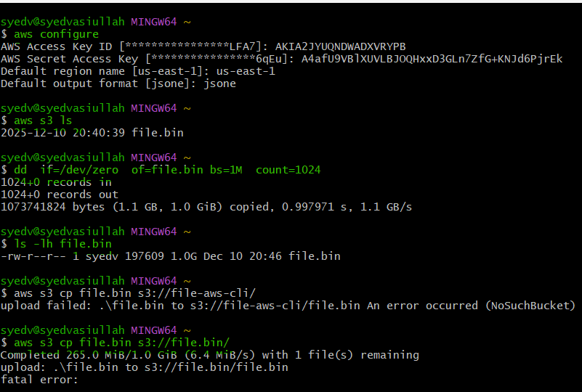

Conclusion
- The primary goal of uploading a 1.0 GiB file to S3 was achieved, as validated by the AWS Management Console. However, the process involved overcoming initial errors related to incorrect bucket naming and CLI syntax. The secondary task of configuring a Lifecycle Rule on vasi-bucket-for-checking was successfully completed, setting up an automated cost optimization policy to transition objects to Standard-IA after 30 days and expire them after 90 days.

